**Health, Safety & Social Issues Related to Robotics**

# Health

Until the 2000s, surgery was thought to be the domain of medical professionals. Until robots entered the operating theatre, if one went to the hospital for a surgical operation, one can expect to be attended by a human surgeon. Since then, other firms, including Intuitive Surgical, Mazor X, and even certain colleges, have responded to the need of hospitals that are gradually but steadily committing to the integration of robotic operating systems.

Robotic surgery, as the name implies, is surgery performed by a robot. It is a minimally invasive surgery, which means it can conduct complex surgical methods through tiny incisions with very little scar tissue. The robot is the instrument in this case, much as a knife or a pair of forceps would be for a good surgeon. The surgeon will sit at the controls of the robot, using high definition 3-D cameras to guide the surgical tools at the end of the robot's arms. Surgeons who use these remote-controlled robots to do treatments have described it to miniaturizing their bodies and travelling inside their patients, allowing them to get a better look at the work they're doing without having to open the patient up. It appears to be an idyllic position, but it isn't all roses and sunshine. Here are the advantages and disadvantages of robotic surgery to give you a better perspective: -

## Advantages

### **Smaller Incisions and Less Trauma**

Because robotic surgery is less intrusive, the patient has less pain and recovers more quickly. The surgical arms are frequently pneumatic, controlled by compressed air and electricity. Each arm's 'hands,' which contain all of the essential surgical equipment, are likewise smaller than human hands, removing the need for huge incisions. Throughout the surgery, the surgeon remains in the operating room. During the procedure, the patient is also monitored by a team of nurses. Surgeries that would ordinarily need a week-long post-operative hospital stay might potentially be converted to outpatient operations. A typical surgery, such as a liver resection, might put a patient in the hospital for a week or more. The use of a robot decreases the hospital stay to one or two days.

### **High Accuracy**

Some surgeries, ranging from orthopedic operations to neurological treatments, need a high level of precision. A single slip of the scalpel or misplaced set of forceps might bring harm or even death to the patient. Surgical robots unlike human surgeons are prone to shaking and other strain-related motions, whereas robots are not. If the controller's hands shake, the machine's software adjusts for the movement, so the operation is unaffected.

Each robotic hand can spin 360 degrees several times, something human hands are incapable of doing. This allows them to move more freely. It has tiny joints that enable each arm to flex like a human wrist. This is an advancement over typical laparoscopic instruments, which are straight and incapable of bending, making them more difficult to operate. It also has a 3D high-definition camera, which provides a clearer picture of the surgical site than would otherwise be possible, even during open surgery.

### **Reduced Surgeon Fatigue**

Surgeries, especially those lasting many hours, are taxing for the attending surgeon. The crew is on its feet for hours at a time, finishing the operation and caring for the patient. Surgery robots allow the surgeon to sit comfortably while doing the procedure. This might help keep surgeons alert and fresh throughout their procedures, minimizing the risk of fatigue-related mistakes and medical negligence.

## Disadvantages

### **Expensive**

Surgery is a costly prospect even in the best of circumstances. The high expense of putting in a robotic surgery system can raise the price of a surgical treatment. Surgical robots are expensive to maintain, and their operation necessitates additional training, which is also costly. Exact figures are difficult to get, but in general, a da Vinci surgical robot operation will cost between $3,000 and $6,000 more than a typical laparoscopic procedure.

### **Latency**

One of the most serious issues with robotic surgery is latency, or the time it takes for the robot to carry out the surgeon's directions. The computer takes a few seconds to communicate with the robotic arms. While this isn't a problem for regular procedures, it can make it difficult for surgeons to respond swiftly to complications that arise during the procedure.

The advantages can ultimately outweigh the negatives with the correct skill and technology. Communication delay is currently the most difficult barrier to overcome before this technology may take a more prominent role in the medical community. Even if the procedure's cost limits its adoption in hospitals, robotic operations will become more widespread, enabling for more accurate microsurgeries with greater precision.

# Safety

Human-Robot Interaction (HRI) brings new obstacles such as safety, autonomy, and acceptability concern due to the ever-increasing need for robots to communicate, cooperate, and support people. To produce safe and precise HRI, robots should be built and developed in such a way that when they operate, they do not cause accidents (i.e., fatalities, injuries, and property damage). As a result, the sorts of robots that interact with people may be classified properly. There are numerous sorts of robots, which are generally classified depending on their functionality, degrees of freedom, workspace, and so on, and are often divided into three broad groups in terms of human interaction. The first category includes Robots in the Wild, in which humans and robots are not collocated, are separated spatially or even temporally, have remote and limited HRI, and require a high level of autonomy; the second category includes Professional Service Robots, which interact proximally with coworkers. The third group consists of personal service robots, which have complicated, rich, and nearby HRI and an intermediate level of autonomy since humans and robots are collocated, i.e., robot assistants to the elderly and disabled persons, as indicated in the image.



Figure 1: Human Robot Interaction

It seems clear that the future of robotics will see a transition away from the separation of man and machine and toward an environment in which operators and robots work together. As a result of this tendency, a safety issue occurs, which is regarded as one of the main issues in robotics, namely the safe interaction between humans and collaborative robots. The adoption of dependability strategies at all phases of robotic solution development is one solution for establishing trust between employees and collaborative robots.

However, dependability is the outcome of the design and development of a robotic system in accordance with the ISO standards, as well as the operation of the robot in close proximity to people without malfunctions.

To that aim, the primary goal of this study is to consolidate and synthesize a significant body of research on safety boundaries in human-robot interaction at all phases of design, building, development, and deployment of a collaborative robot. Thus, the purpose of this manuscript is to organize recent literature by describing the required levels of safety during human-robot interaction, concentrating on the core functions of collaborative robots when performing processes, concentrating on the methods that ensure psychological safety during human-robot collaboration -appropriate for robot behavior adjustment-, and analyzing the psychological parameters of robot adoption in industrial and social environments.

We present a taxonomy of five primary categories based on current work on safety features to reduce the danger of human-robot interaction: Perceptions of Robots for Safe HRI, Cognition-enabled robot control in HRI, Action Planning for safe travel with people, Hardware safety features, and —Social and Psychological aspects Furthermore, particular studies connected to task-analytic models and classic hazard analysis methodologies, such as Failure Mode and Effects Analysis (FMEA), Fault Tree Analysis (FTA), Hazard and Operability Study (HAZOP), and Systems Theoretic Process Analysis, have been examined (STPA).

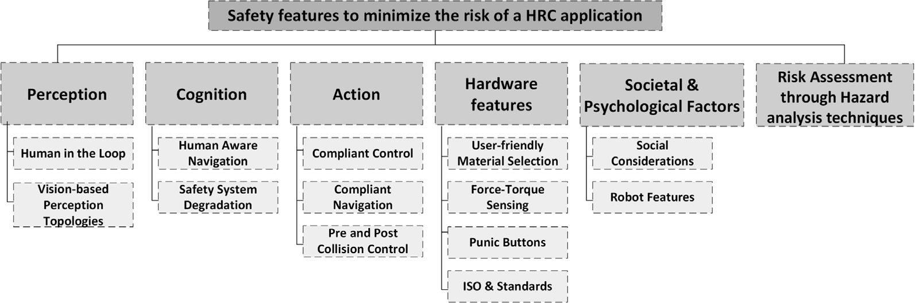

Figure 2: Methods Providing Safety in HRI

There are different hardware safety features applied in the modern robotics, the force and torque sensing techniques are used to ensure safety. Machine learning is used to map the environment of the robot using the SLAM. Thus, the robot can sense the presence of the human in its workspace. These techniques are found to be very useful in this regard and being widely used. Another very widely used technique is the mechanical compliance technique. In the mechanical compliance the stiffness of the robot and other aspects are adjusted in such a way that it should not apply force that is necessary to interact with and object. For example, for a robotics gripper its stiffness can be adjusted such that it should apply less amount of force to pick an egg and more to pick a piece of metal.

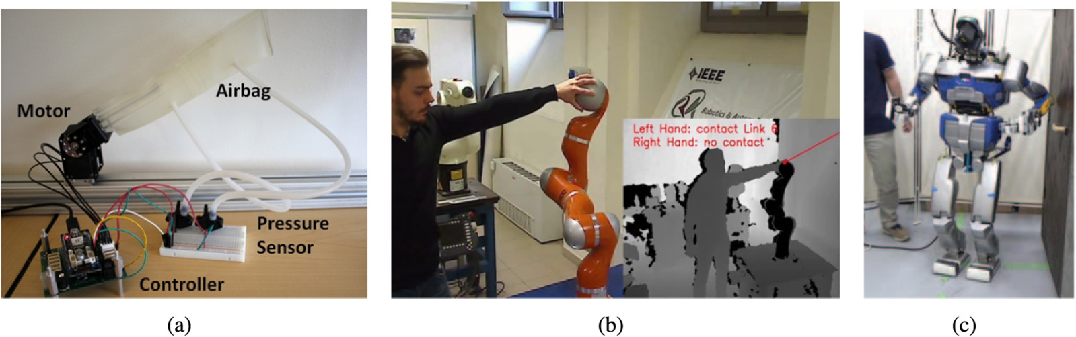

Figure 3: Safety Features in Robots

# Society

## Robotics for Extreme Environments

Our earth is becoming more susceptible as a result of both natural and man-made calamities. Such catastrophes are unavoidable as the world becomes more linked through modern transportation and quicker mobility of people. It is critical to quickly understand how we can avert disasters and support victims in the early hours, when timely relief can save lives. Robotic technology development in harsh settings, such as nuclear inspection and decommissioning, offshore energy and maintenance, space exploration, and deep mining, has attracted a lot of interest in recent years.

## Robotics in Agriculture

According to the United Nations, the world population will exceed 10 billion by 2050, increasing demand for agricultural goods by more than 30%. The complexity of the task is increased by the availability (or lack thereof) of labor and natural resources, leaving scientific and technological developments (e.g., agricultural robots) as the sole method of fueling a third agricultural revolution. Agricultural robots, powered by GNSS, SatEO, and Satcom technologies, are positioned to be at the forefront of the third agricultural revolution, not by displacing farmers, but by boosting the farmer's added value while increasing output and optimizing natural resource usage.

## Infrastructure Monitoring

Significant quantities of sensors and sensing systems have been created during the last several decades to monitor and analyses the state of buildings. Structural health monitoring (SHM) is an important component in civil engineering for ensuring the safety and integrity of civil structures such as buildings, bridges, power plants, offshore structures, and tunnels. Modern sensing, automation, and robotic technologies may considerably simplify infrastructure system construction automation. SHM-specific robots have just lately been created, using particular locomotion systems to permit movement in the structures to be examined.

## Transportation

Robotics are transforming the transportation and logistics industries. Robots can drive autonomously to a location and determine their precise position and path, thanks to radio transmitters, vision cameras, magnetometers, LiDAR, lasers, digital maps, navigation systems, and attached sensors to identify obstructions. They can recognize dangerous conditions and respond accordingly, sharing the path with people and other cars, thanks to sensors. Transport automation might improve safety, dependability, and efficiency. While need for drivers and pilots will decline, new professions in control and management will emerge. However, in order to have the full impact, infrastructure, legislation, and mindsets must change. Companies are already investing to transform the face of private and commercial travel, from self-driving vehicles to robot buses that are currently being trialed on European streets to drones that are expected to build a whole new transport network in cities.

## Social Care

There are numerous successful tech innovations taking place on the frontlines of social care, but the current underutilization of both medicinal and digital technology means that there is a real opportunity to unleash a new wave of innovation that could have a revolutionary impact on how care is delivered and how patients interact with professionals to manage their own health and care. Robots and autonomous systems, in conjunction with AI, linked data, and digital infrastructure, have the potential to revolutionize the delivery of social and medical care to the old and disabled.

## Soft Robotics

Soft robotics is inspired by creatures such as worms, starfish, and snails, as well as animal body parts such as elephant trunks, octopus’ arms, and mammalian limbs. Soft robots are distinguished by their compliant nature due to the employment of elastic and soft materials such as rubber or electroactive polymers in their bodies. When opposed to hard robotics, this softness has several advantages and downsides. Soft robots provide more dexterity, greater movement variety, usage in previously inaccessible areas, and increased safety. Soft robots, on the other hand, are more difficult to manage due to their bodies' nearly unlimited degrees of flexibility. Soft robots come in a range of shapes and sizes, as well as applications with high commercial potential, such as robotic muscles, climbing, wearable, prosthetic, and edible robots.